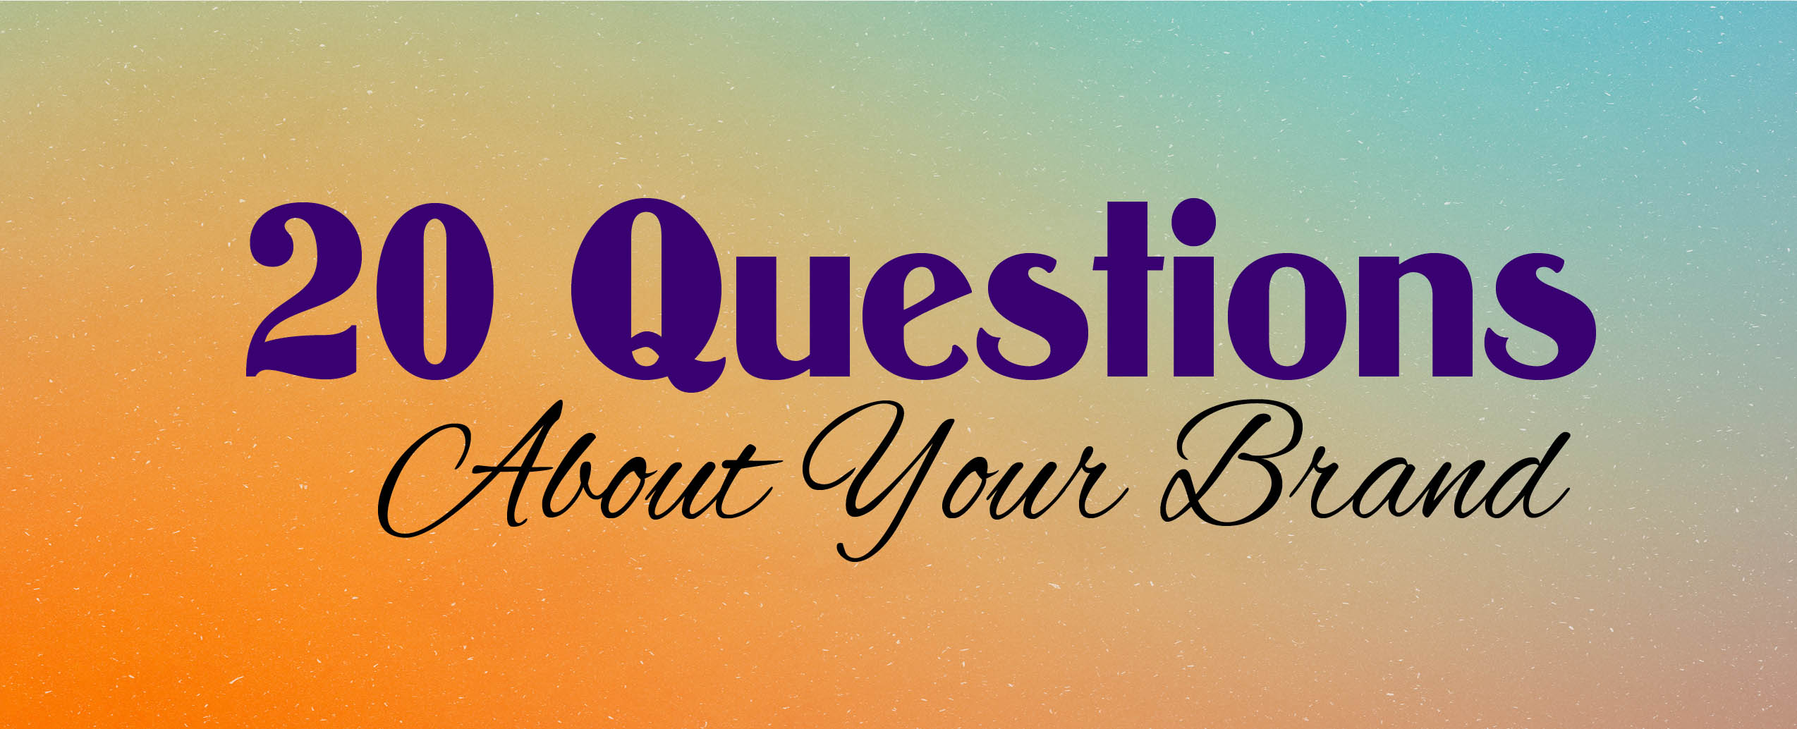

“Branding Definition: The marketing practice of creating a name, symbol or design that identifies and differentiates a product from other products.”
~ Entrepreneur Staff

“Branding is the expression of the essential truth or value of an organization, product, or service. It is communication of characteristics, values, and attributes that clarify what this particular brand is and is not.” ~ James Heaton

20 Questions © 2020 Jan Carpenter Tucker • All rights reserved
J.L. Carpenter Design • 619.253.3070 • janct@cox.net • www.janscreativebest.com

Proud recipient of the 2001 Edward L. Bernays Mark of Excellence Award
from the Public Relations Society of America, San Diego Chapter

A. Please answer as many of the questions as you can on this sheet or another document.
B. Add any other information you think is important.
C. Save your document with an identifying name (e.g. Toni’s Cupcakes Brand.docx)
D. Email your document to Jan Carpenter Tucker janct@cox.net

1. What is your product or service?

2. Who will use your product or service?

3. Who is the main audience you are talking to?

4. What message do you want to communicate?

5. What do you want people to do, feel or believe about you, your company, your product or service?

6. What do you want to be known for?

7. What qualities do you want people to associate with you?

8. What feeling do you want to evoke in people?

9. Is your brand tied to anyone’s personal identity? If so, give specifics.

10. Are there colors that will help convey your message?

11. Are there images, colors or ideas to include or avoid? If so, explain.

12. What adjectives describe your brand (e.g. reliable, youthful, caring)?

13. Who else offers a similar product or service (who is your competition)?

14. Do you have copies or links to your competition’s materials or website? Please attach photos or include links.

15. What makes your brand or business stand out in a crowd?

16. What action do you want people to take?

17. What is the best way to reach your target audience?

18. What end result do you want to achieve with your brand?

19. How will you know if your branding or business image is effective?

20. What is your budget for this project?

